Executive Summary: GLEDC Membership Development Survey
The Great Lakes Economic Development Council (GLEDC) conducted a targeted survey to understand the makeup of its membership, identify membership preferences, set organizational priorities, and highlight the professional challenges and interests of its members.
The survey was conducted in February-March of 2024. A link to the survey was sent to over 5000 economic development professionals in the Great Lakes region, to members of the Great Lakes EDC, and it was shared on the GLEDC’s social media channels.
With a 100% completion rate among 56 respondents, the survey results offered deep insights into the council's operational and strategic positioning.

Membership Composition and Geographic Distribution
- A majority of respondents (55.4%) are current GLEDC members, indicting a high level of interest and active engagement from within the organization.
- The potential for membership growth is promising, with 17.9% non-members and 19.6% considering membership, suggesting there are outreach opportunities.
- Survey responses were received from all Great Lakes states and provinces except for Quebec. Forty-two percent of all responses came from Ontario (21.8%) and Michigan (20%), indicating strong regional engagement and potential areas for further development or targeted initiatives.
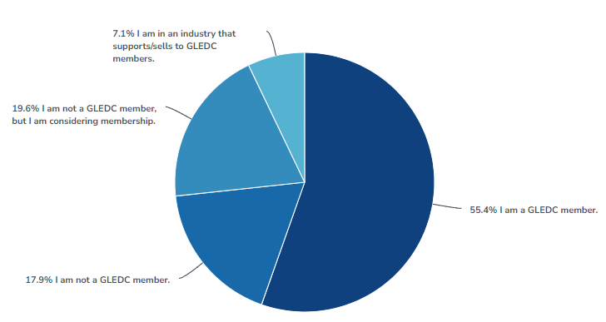

Quebec may present a membership challenge as it is also the only state or province for which the GLEDC does not have board representation. In conversations, many from Quebec have stated they do not consider themselves part of the Great Lakes region despite the importance of the St. Lawrence Seaway to the region.

Organizational Goals Prioritization
Survey participants were asked to prioritize the strategic goals for the Great Lakes EDC from six available choices. The rankings were:
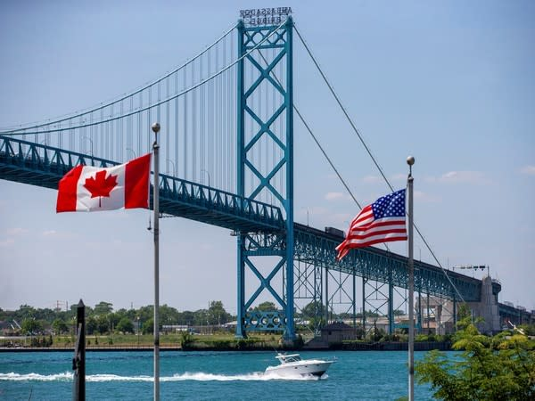
- Promote the region's economic competitiveness as a place for new and expanding businesses.
- Be an active voice to shape regional policy and programs that strengthen the region’s desirability for new investment.
- Promote collaboration between Great Lakes communities.
- Develop tools and research to support economic growth in the region.
- Unify the region in a vision for economy shifting efforts.
- Support sustainable development and protection of natural resources.
The emphasis on these goals suggests that GLEDC should focus its efforts on initiatives that enhance the region's attractiveness for business, advocacy for the competitiveness of the region and encouraging cooperation between states and provinces.

Membership Structure Preferences
Several membership related questions were asked regarding the preference over organizational versus an individual membership structure and pricing for each.

Organizational membership is preferred (51.8% over 39.3% for individual membership). The reasons for this were not explored but an advantage to GLEDC is that organizational memberships allow multiple employees from the same organization to access membership benefits. This broader engagement can enhance the professional development of a wider range of staff and can have a more substantial impact on the organization's overall strategy and operations.
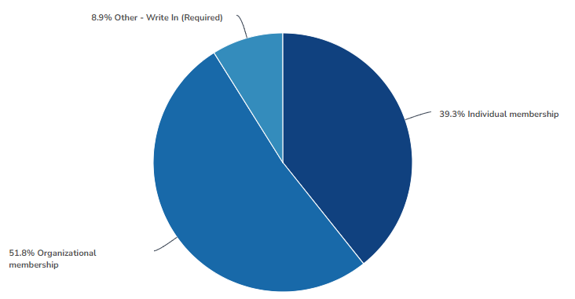
Membership Pricing – Individual

For those preferring the individual membership model, most respondents (68.1%) recommended a rate of $250 per year for membership. The next two largest responses were $150 (10.9%) and $50 (7.3%). Some of the comments made were:

- Seems in in line with other associations
- I haven't found much use for either GLEDC or Midwest EDC. You need to differentiate between these two, IEDC and CDFA.
- I say individual as in an individual department of a city. Most economic developers outside of larger cities are one-man bands. Price it right and you can do better with lots of small / mid-sized than a few bigger fish. Keep it reasonable and you'll be fine!
- I think that the value could increase if for instance there were opportunities for education or continuing education credits (AICP, CEcD, other). Maybe a supporting member is $150, maybe a contributing member is $250 and would have limited access to free webinars or virtual networking. This would provide a value over other offerings (some of which are already free), and expand awareness of GLEDC, better introduce people and practitioners to its mission, and result in much better data and analysis.
- Ideally, both options would be available. If companies/municipalities are unable/unwilling to pay membership fees, then having an accessible individual option is a great alternative.
- If we are going to require a membership fee, I recommend starting with a lower fee and see what the market is open to. We can adjust depending on feedback and events we have throughout the year.
- Simply as I am Semi-retired now
- The Association of University Business and Economic Research (AUBER) sets their membership for individuals at $100.

The preference for an individual membership model may be because they are perceived to be portable, or cater to the specific professional development needs, career goals, and personal interests of the individual.

However, the preference for an organizational model suggests the GLEDC could consider developing benefits and programs tailored to organizational needs which could lead to increasing engagement and expanding the member base.

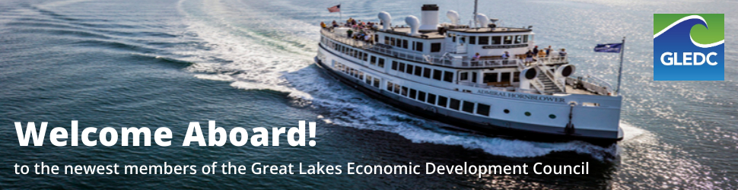

Membership Pricing – Organizational

Although the organizational membership model was slightly preferred over the individual one, respondents did not offer any suggested pricing. They did offer the following comments:

- $750 for 3 members seems fair. Could increase as we grow and offer more value to our memberships.
- Depends on the size of the org. Please see places like Economic Developers Council of Ontario for how they structure their org. rates.
- It really depends on the size of the organization I would think.
- Sliding scale based upon size of community or $ value of organization.

Professional Challenges
Respondents shared a wide variety of challenges they face as economic development professionals in the region such as utility capacity building, regional project and population retention, and economic advocacy. See all comments below.

- Building Utility Capacity and working with MISO to advance projects
- The region keeps losing projects and population to other states yet there are many positive new developments and emerging technologies. We need to stem the tide and help return the region to its economic prominence.
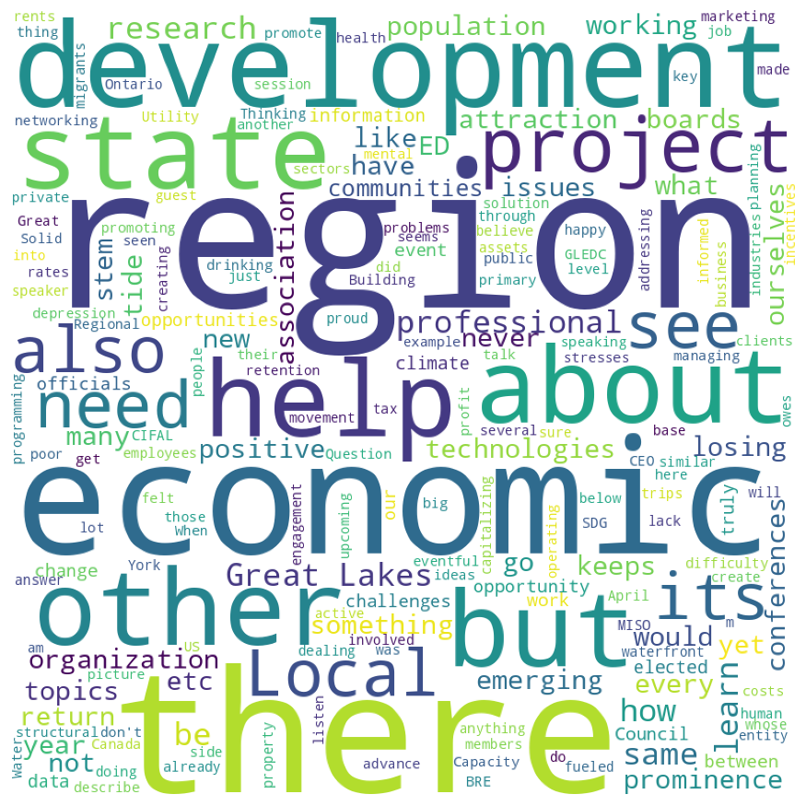
- When I was an active CEO managing an ED organization I felt the professional associations did a poor job promoting the human side of economic development. We go to the same conferences every year and listen to the same ideas every year, and learn how to do attraction, BRE , etc. But we never learn about ourselves. We never talk about the stresses and difficulty dealing with people, boards, employees, etc. I have seen several professionals go through drinking problems, depression, and other mental health issues. Is that something and professional association owes its members? I 'm not sure the answer, but I would be happy to help create a solution. As an example, in Question 8 below there are a lot of great programming topics but I don't see anything addressing what I describe here.
- Water level
- Working waterfront communities and creating eventful conferences on key topics. How to get GLEDC involved for those opportunities. Also, for an upcoming speaking engagement with CIFAL York - SDG session for April 16-18. To have a guest speaker opportunity for the event and promote the organization.
- Regional business retention and attraction
- Research into big picture structural change. Solid base of information about the Great Lakes and their primary assets.
- Thinking about planning for and capitalizing on climate migrants / industries whose movement will be fueled by climate change
- The lack of informed clients in the private, not-for-profit, and public sectors.
- Local data (rents, operating costs, property tax rates) Local incentives
- There's already Economic Development Council of Ontario and Canada and believe there something similar in the US just seems like another entity doing the same thing.
- I am proud of our region, but also see extremely stark differences between different states/provinces. I think more information, research, data, on how our region truly works, could be advantageous to truly defining ourselves as a region.
- research focused on issues impacting the Great Lakes region
- The push for electrification. Need to serve as an advocate to educate elected officials of the challenges posed by this.
- closer collaboration with State counterparts
- There is a knowledge gap between Boards/Councils (elected officials) and the planners, administrators, and ED directors that can lead to unnecessary project delays. There is an opportunity to provide joint-learning opportunities to help both groups learn to work collaboratively.
- Economic Development
- understanding what other communities connected to the Great Lakes are experience as far as economic challenges and wins.

These responses indicate a need for GLEDC to address infrastructure, regional marketing, and policy advocacy, potentially through targeted research, lobbying, and promotional campaigns.

Programming Interests

Participants were asked to provide preferences on the frequency and cost of four different types of programming activities – webinars, conferences, site tours and virtual networking. The results were:

Webinars – Webinar frequency ranged from two to twelve times annually. Most responses were for quarterly (31.6%), bi-monthly (26.3%) or monthly (26.3%).

Pricing suggestions - The most suggested price for members was free (35%), followed by $25 (25% and $50 (15%). The suggested prices ranged from zero to $150.

The most suggested price for non-member participation in webinars was $50 (35.3%), followed by $25 (17.6%0 and $40 (11.8%). The prices ranged from zero to $300.

These results suggest that respondents feel that non-members should be charged more for services at roughly double the rate of members.

Conferences – Respondents were also asked about the frequency and cost of in-person conferences. Frequency ranged from one to six times annually, with the highest percentage suggesting one conference per year (60%). The next highest response was twice annually (25%) followed by 3 conferences per year (10%) and six conferences per year (5%).

Pricing suggestions - Conference pricing was much more diverse, most likely due to perceptions respondents had regarding length and location of a conference.

For members of the association the price suggestions ranged from $50 to $1000 with an average of $400. This was also the price receiving the highest percentage of responses (25%). Half of all responses fell between the range of $250 to $500.

Pricing suggestions for non -members of the association ranged from $50 to $1295 with the average being $605, or about a 50% premium over member pricing. Half of all responses fell between the range of $500 to $750.

Site Tours - Respondents were also asked about the frequency and cost of in-person site tours. Frequency ranged from one to 24 times annually, with the highest percentage suggesting two per year. Pricing for members ranged from zero to $500 with the highest percentage being both $100 and $150. For non-members, the pricing ranged between $10 and $500. Forty percent of respondents priced this between $300 and $500 while another 40% priced it below $75.

Virtual Networking/Collaboration - Respondents were also asked about the frequency and cost of virtual networking and collaboration meetings. Frequency ranged from one to 12 times annually, with the highest percentage suggesting bi-monthly sessions (31.6%). The next two highest responses were quarterly (26.3%) and monthly (15.8%)

As far as pricing goes for these virtual networking events, there was a strong preference that these be free for members of the association (50%), A cost of $25 was suggested by 18.8% of respondents as was the price of $50.

For non-members, 25% said it should be free, with the remainder suggesting prices ranging from $25 to $250. The most suggested price was $25, selected by 20% of respondents.

Program Topics of Interest

Respondents were provided a laundry list of potential program topics to choose from and they indicated strong interest in rural economic development, regional competitiveness, and innovation, indicating a desire for programming that addresses both broad strategic themes and specific, actionable topics. Here are the top twenty areas of interest:
Rural Economic Development | 46.20% | 24
Regional Competitiveness | 38.50% | 20
Benchmarking the Great Lakes Against Other regions | 38.50% | 20
Innovation in the Great Lakes | 34.60% | 18
Branding the Great Lakes region | 34.60% | 18
Economic Forecasting for the Region | 32.70% | 17
Industry Sector Overviews | 30.80% | 16
Site Selection Trends | 28.80% | 15
Talent Attraction Strategies | 28.80% | 15
Solutions to Common Challenges | 26.90% | 14
FDI in the Great Lakes | 26.90% | 14
Marketing & Attraction | 25.00% | 13
Tourism as Economic Development | 23.10% | 12
Coastline/Water Level/Water Quality Issues | 21.20% | 11
Downtown Revitalization Trends | 21.20% | 11
Land Use Issues | 21.20% | 11
Transportation Advantages in the Great Lakes | 19.20% | 10
Community Development | 19.20% | 10
Workforce Development | 19.20% | 10
Supply Chain Strengths in the GL | 19.20% | 10

This variety of interests suggests that GLEDC could and should offer a wide range of programs, from high-level policy discussions to practical workshops on emerging trends and technologies.

Conclusion
The GLEDC survey garnered valuable insights into understanding members and member candidates’ preferences and challenges. It sharpened the focus on strategic priorities to enhance the organization's impact in the region. The findings also provide GLEDC with invaluable information on membership composition, organizational goals, member preferences for structure and pricing, and the professional challenges and programming interests of members and potential members. The following summary encapsulates the top eight survey findings, offering a roadmap for enhancing GLEDC's service offerings, member engagement, and regional impact.
Summary Findings
- Majority Membership Engagement: A solid 55.4% of the survey's respondents are already members of the GLEDC, which indicates a strong core of active and engaged professionals within the organization.
- Growth Potential: With 17.9% of respondents not currently members and an additional 19.6% considering joining, there's strong potential for growth.
- Geographical Insights: Responses were received from every Great Lakes state and province except Quebec, with Ontario and Michigan leading the pack.
- Quebec's Quandary: The lack of engagement from Quebec, alongside no board representation for the region, is challenging. Despite its crucial location, Quebecers don't necessarily see themselves as part of the Great Lakes region.
- Strategic Goals Alignment: Members are most excited about boosting the region's business competitiveness, shaping supportive policies, and fostering community collaboration. These goals highlight a collective vision for a more competitive, united, and economically vibrant Great Lakes region.
- Membership Model Preference: Most survey respondents (51.8%) prefer an organizational memberships model 51.8% preference but did not indicate suggested pricing. For those preferring an individual membership model, the suggested price for membership was $250.
- Professional Challenges: From utility capacity to economic advocacy, the broad range of challenges shared by respondents paint a picture of variety and complexity.
- Programming Preferences: Respondents indicated preference for a mixed bag of webinars, conferences, and networking events, with a leaning towards educational and strategic content.
Next Steps
Given this fresh data and insight, the next steps for the GLEDC management team and Advisory Council is to draft a series of recommendations for moving forward. With this snapshot of where we stand today, development of an action plan for the next steps will guide us in our journey to develop a strong association serving the needs of economic development professionals and the communities they serve across the Great lakes region.

